

Proving What Works: Building the Decision Layer for OceanX Education
IS615 Digital Transformation Strategy | Individual Report | Tan Ghim Chong | Group 4

1. Problem Framing & Linkage
Our group was asked to help OceanX Education (OXE) move “from one-off programmes to a repeatable digital system”. We designed three connected interventions: a Data and Impact System, a Modular Content Platform, and Alumni Engagement. This report tests one capability from the first: an AI-assisted Asset Dashboard.
Problem and pain point: OXE collects learner and educator feedback differently for every programme, keeps it in Excel and Notion, and reads it by hand. KPIs are “oral”. OXE cannot tell which content works, so every new partner means manual rework, and sponsors cannot see what their funding achieved.
How Might We: How might OceanX Education turn its content and data into something partners can reuse and trust, so that ocean literacy and stewardship outcomes can be proven and scaled?
North Star Impact: Partners can prove, reuse and adapt OceanX content, so impact grows without scaling the team proportionally. North Star Metric: % of programmes where centralised data informs a content or resourcing decision. Our midterm listed five metrics, most of which measured activity (the “measures access, not impact” trap), so I argued for one that tests whether behaviour changes. The Asset Dashboard is a direct test of it.
5Ps most affected (Lecture 1):
- Process (most affected): feedback is read manually, with no standard way to decide what to keep, change or drop.
- Platforms: data is split across Excel and Notion, and Salesforce is only a pilot.
- Policy: no standard KPIs, so programmes cannot be compared.
- People: a small team, with one person owning all data architecture.
- Partners: educators give feedback but never see it used, which weakens the feedback loop.
Why this idea first: The data gap is not one problem among many. It is the root cause: OXE cannot repeat what it cannot see working. Both midterm reviewers asked which ONE capability we would build first. I recommended this one because Interventions 2 and 3 depend on its data, it uses mature technology, and it is feasible for a small team in five weeks.
Stakeholders and business value:
- Content managers: turn a pile of feedback into a Reuse, Adapt or Drop decision in minutes instead of hours (efficiency).
- Partners and educators: each package improves on the last, supporting reuse and renewal (stakeholder adoption).
- Funders: evidence of learning impact for reporting, supporting grant and sponsorship income.
- OXE as a non-profit: built on free and open tools, so running cost stays near zero.
Strategic fit: Applying the Run/Grow/Transform decision tree literally, this extends an existing capability to existing partner types, so it is Grow. The lecture rule “be the second mouse for Run and Grow” shaped the design: mature, proven tools and human approval on every AI output, since AI content tools still sit near the peak of the Hype Cycle.

2. Experiment Design

Hypotheses
H1 (decision usefulness): If feedback is turned into AI decision cards, content managers will make Reuse, Adapt or Drop decisions that match the evidence more often, and with more confidence, than when reading raw feedback.
H2 (safe use): Content managers using AI cards will still reject a recommendation that contradicts the evidence, rather than approve it blindly.
Why these hypotheses: My first hypothesis tested whether the AI was accurate. Professor Kiru pointed out that accuracy is not the business question. The real question is whether the tool helps a content manager make a better decision. I rewrote the hypothesis around decision usefulness, and accuracy became a pre-test quality check. This reshaped the build: I needed a raw data view to compare against, an answer key, and a reason for testers not to just trust the AI (H2, the risk OXE itself raised about AI).

Scope & Method
- Target users and sample: content managers who decide what goes into the next package (OXE content staff, with external content managers as proxies). 3 testers, 6 decisions each (18 decisions).
- Method: within-subject A/B test on the functional prototype. Each tester judges 3 items with raw data only (A, today’s way of working) and 3 with AI cards (B). Comparing the same person across both views isolates the effect of the AI card from individual skill.
- Scenarios: six university content pieces, balanced (2 Reuse, 2 Adapt, 2 Drop) so guessing one answer gives no advantage. The answer key is fixed in advance by written decision rules. One is a “trap”: a video learners loved but learned little from, testing whether people confuse engagement with learning.
- Counterbalancing: sets and order are swapped across testers (T1 AI first; T2 and T3 raw first, with sets swapped for T2) to control for content difficulty and learning effects.
- Planted error: one AI card per set is deliberately wrong, while the numbers and quotes on it stay true. If every card were right, testers could click Approve and the test would prove nothing.
- Data: about 30 learner and 6 educator responses, mostly labelled sample data, shaped so each scenario has a clear evidence pattern.

Metrics & Success Thresholds
Metric | How it is measured | Success threshold
Correct and confident rate (H1) | Decision matches the answer key with confidence 4 or 5 (1 to 5 scale) | 80% or more in the AI view, AND higher than the raw view
Wrong card caught (H2) | Tester rejects the planted card and picks the evidence-based answer | At least 2 of 3 testers
Time to decide (supporting) | Seconds per decision, logged automatically | AI view faster than raw view

Data Collection & Decision Rules
Every decision is logged automatically with the view, choice, confidence, a one-line reason, seconds taken and the AI recommendation shown. Afterwards, each tester answers three questions: which view helped them decide faster, whether they trusted the AI, and what would make it useful in their work.
Result | Decision
H1 and H2 both met | Pilot: one real university seminar with real learners
H1 met, H2 failed (testers approve the wrong card) | Refine: make the evidence more prominent, add a “check before approving” prompt, then retest
H1 not met: AI view no better than raw data | Pivot: keep data capture and the dashboard, drop AI recommendations
Testers see no value in either view | Park: revisit once OXE has a standard KPI set

3. Functional Prototype: Asset Dashboard
Purpose: help an OXE content manager decide whether each piece of a content package should be Reused, Adapted or Dropped, based on evidence. Live at oceanx-prototype.vercel.app. Built with a web app (React), a live database (Supabase), an email service and free language models. These match the low-code equivalents: Power Apps (interface), Dataverse (data), Power Automate (email) and AI Builder (AI output).
One workflow, end to end: a partner adapts a content package, an automated email sends the learner quiz and educator form links, learners and educators submit feedback, AI generates decision cards, and the content manager approves or rejects them on the dashboard.
Data capture: a learner page (5-question pre-check, post-class quiz, “which activity helped most”) and an educator form (kept, changed or skipped, plus a 1 to 5 rating per component). This answers the midterm question of which data fields are needed to run KPIs.
Hybrid RAG pipeline: numbers come from SQL views, so they are never invented by the model. Learner comments are retrieved by vector search. A free language model then writes a decision card: a recommendation, the reason, real quotes and four metrics.
Guardrails: the model is never told the rule-based answer, so its reasoning is checked independently. Quotes must appear word for word in retrieved comments, and comments must name the component they describe. Human in the loop: Approve or Reject on every card, with a raw data view beside it.
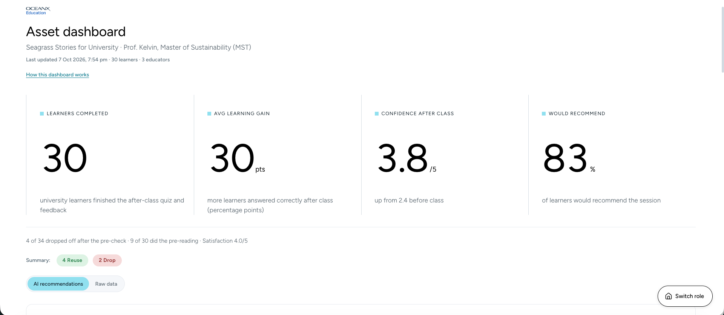
Figure 1. Asset Dashboard
Quality check before testing: numbers 10/10 correct. Quotes and claims 10/12 on the first run: the two errors came from untagged comments linked to the wrong activity. After adding a keyword attribution guardrail: 12/12. AI recommendations matched the answer key 6 of 6. This showed me that RAG errors often come from retrieval, not generation.
Table | Key fields | Role in the test
learner_prechecks, learner_responses | session_id, answers Q1 to Q5, confidence, helped_most, comment, is_sample | Learning gain per component
educator_responses | component_id, kept / changed / skipped, ratings, note | Educator use and fit
insight_cards | component_id, recommendation, why, quotes, metrics, guardrail_ok | AI output shown on cards
tester_decisions | tester_code, view, decision, confidence, reason, seconds_to_decide, card_recommendation, created_at | Trackable experiment signal

Fully functional: all four user flows, live saving and reading of data (new records appear in the Raw data view), the automated email, AI card generation with guardrails, and tester mode with automatic logging.
Simulated: about 25 of 30 learners and 4 of 6 educators are labelled sample data; the two wrong cards are planted with a test-only flag; and the package email sends instantly, whereas in practice OXE would approve it first.
Use in the experiment: each tester opens their own link, reads a short intro on Reuse, Adapt and Drop, makes six decisions in a side panel, and only sees the answers after their decisions are saved.

4. Decision & Next Steps
Proposed decision: Refine, then test. The prototype works end to end and passed the AI quality check (numbers 10/10, quotes 12/12, 6 of 6 recommendations matching the answer key), so it is ready to test. But H1 and H2 have not yet been tested with content managers, because OXE staff were unavailable during the testing window. Moving to a pilot now would skip the evidence the decision rules require.
Next steps:
- Run the planned test with three content managers (links and logging are ready) and apply the decision rules above.
- If H1 and H2 hold, pilot with one real university seminar so the cards draw on real learners instead of sample data.
- Design a scalable human review step (review by sampling, escalate only flagged cards), so approval does not become a bottleneck as programmes grow, a question raised at the midterm.
OXE’s challenge was never a shortage of good content. It was not knowing which content works. Building the decision layer first, with AI as a summariser rather than a decider, gives OXE a credible, evidence-backed first step toward a repeatable system.

